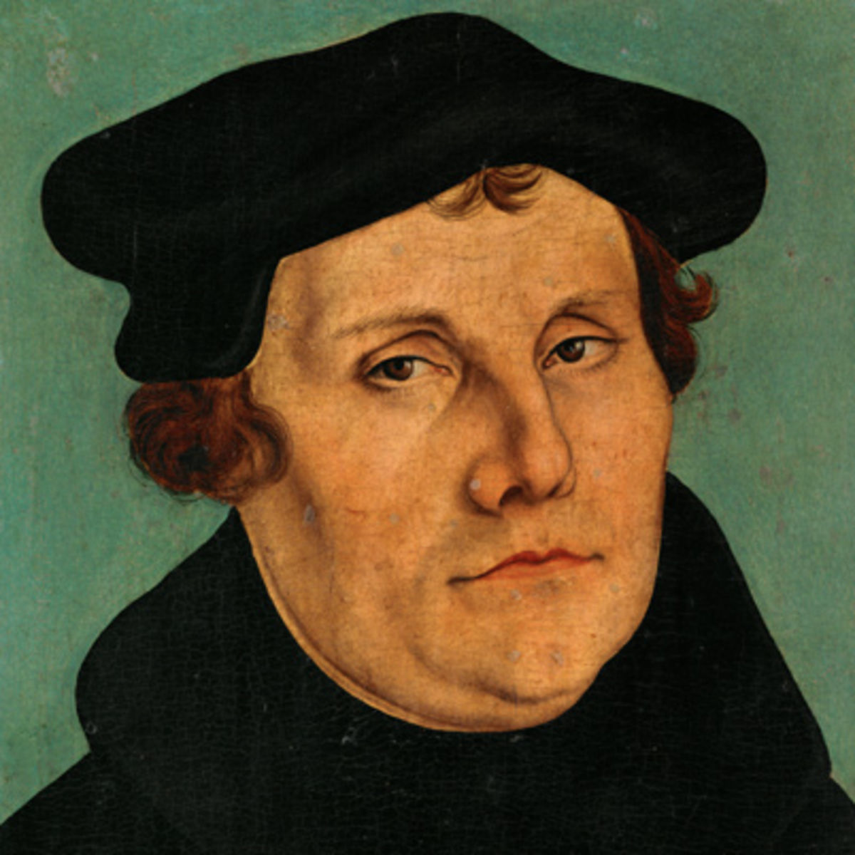

Edict of Worms

Leo X

95 Theses

**3 Tenants**

Luther’s Enlightenment

His Path

Defining Moment

Internal Struggle

Early Life